**HOW TO GET A TRIDENT IN MINECRAFT**

In this article, you will come to know **how to get a trident in Minecraft**. Minecraft is a famous 3-D video game and it is an educational type that sharpens many intellectual skills. Unfortunately, there is no way to craft a trident in Minecraft. The only means to get them is **by killing drowned**. There is an 0.53% chance of getting a trident after killing a drowned holding the trident. Players can improve their chances by using a looting III sword for killing these mobs.

Tridents were added to Minecraft in the Aquatic update. Compared to all other weapons in the game, the [trident](https://www.sportskeeda.com/minecraft/minecraft-trident) is a unique weapon, and one of the rarest items. Fighting aquatic mobs underwater can be scary. Players have to keep their breathing in check and cannot use a bow underwater. **Tridents are the perfect weapon for underwater battles.**

With Impaling V Enchantment, tridents can deal massive damage to aquatic animals. On a rainy day, players can fly using a riptide-enchanted trident. Using the channeling enchantment, they can summon lightning strikes on mobs during a thunderstorm. Here's how gamers can obtain this powerful weapon.

**REQUIRED ITEMS:**

* 3 Lapis Lazuli
* 1 Trident

**HOW A TRIDENT LOOKS:**

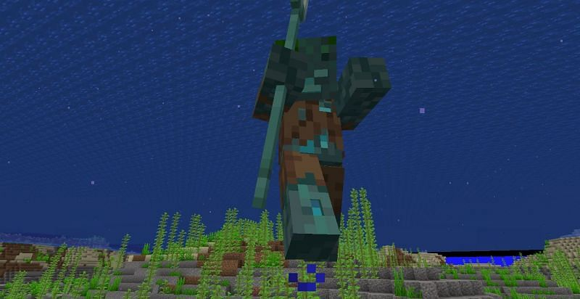

**Way to get a trident:**

The first thing to mention about trying since they are and then the craftable item in Minecraft. So, the only way to get them is to kill a drowned Bob that is holding a Trident. How the Drowned spawn is in all ocean biomes including deep variants at light level 7 or below. In the java edition they spawn in groups of 1 in ocean biomes they spam below y while levelling 58, so they spawn at least 6 blocks below sea level. Sea level being y level 64 drown can also generate as part of certain structures in the ocean ruins. Cold ocean ruins generated normal cold and frozen ocean biomes as well as their as deep variants. Warm ocean ruins generated warm lukewarm and deep lukewarm ocean biomes most of the structure’s generators drowned and there can be 1 to 4 in each structure.

One thing to keep in mind with ocean ruins is that depending on the structural integrity there may be blocks missing and the drowned may not be in these structures drunk and also spawn in rivers responding macaques are higher in rivers than in oceans. The reason for this is that rivers have a small area to spawn. So for drowning to spawn in a river they need a higher likelihood to spawn than in an ocean biome also the part about spawning below y level 58 does not apply to rivers.

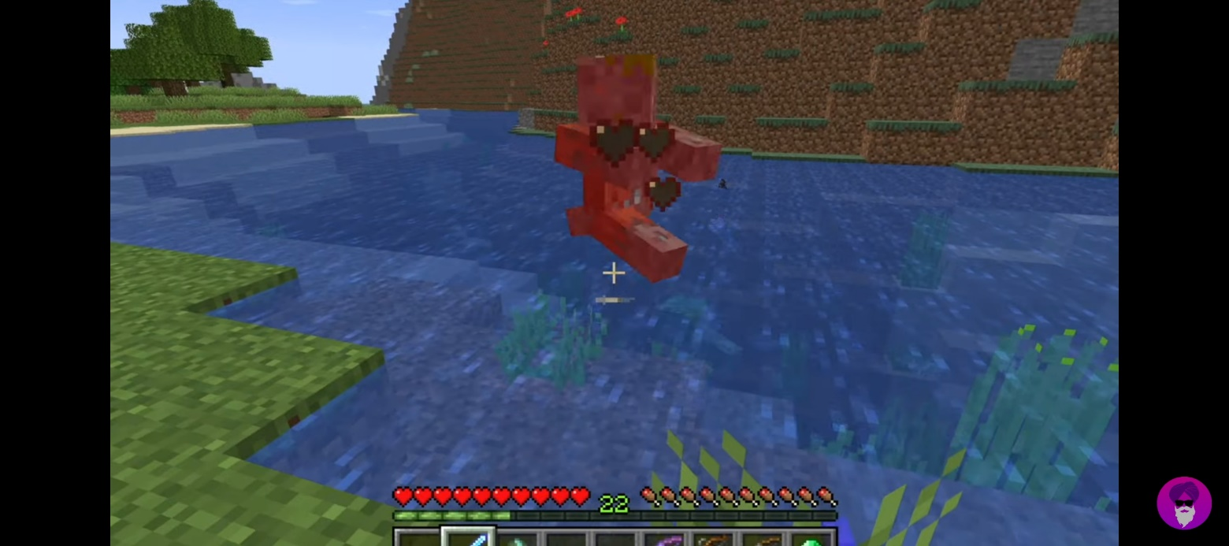

Taking this into account if you plan on farming drown poor tridents the best location is a river bio. As they are more likely to spawn them. Once you have found round there's a 6.25% chance in the java edition. Drowned having a trident in the hand when they spot if a drowned has a trident, they can do a lot of damage and normal difficulty they can throw it right in every 1.5 seconds and do 9 damage. You cannot pick up the thrown tridents. When you kill a drowned there is a 5.5% chance of it dropping the trident. You can increase this with the looting enchantment which is a sword enchantment the enchantment increases the drops when killing a mob with the Trident this increases the chance of it dropping by 1% per level of the enchantment. The maximum level is 3. At level 3, you have an 8.5% chance of getting a trident. Another thing with the drowned is that even though they are found in the water they are in the undead mob category.

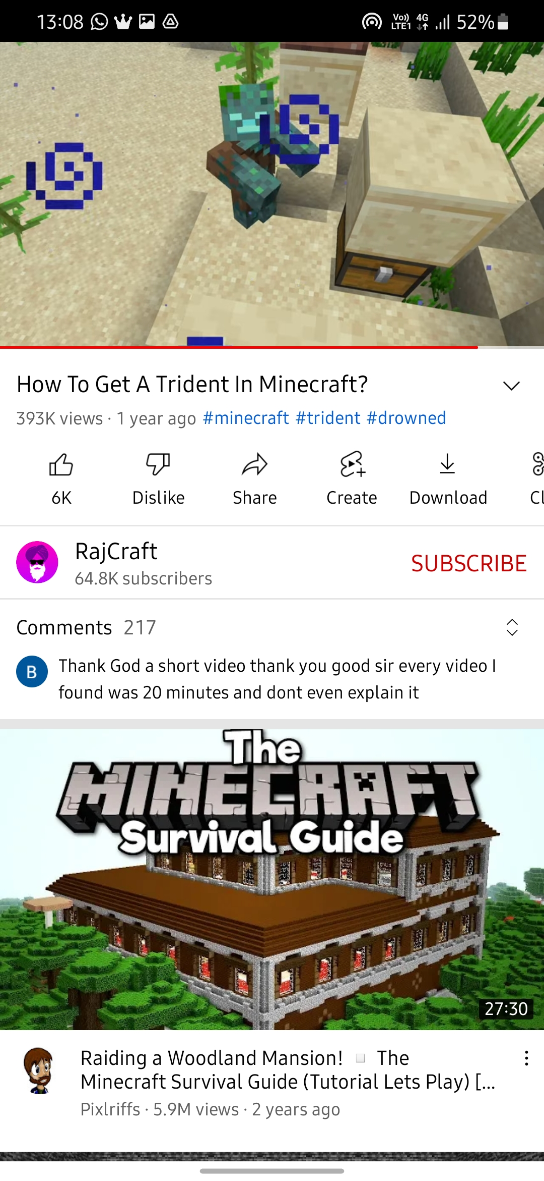

This means they are affected by this smite enchantment, which is an enchantment for the axe and sword it increases the damage to undead mobs by 2.5 per level of the enchantment the maximum level is five, so it does 12.5 extra damage to undead mobs. It is also incompatible with the pain of arthropods and the sharpness in chairman's mean you can only have one of the three enchantments on your accent resort.

The last part of this is that when the trident was first added you can convert zombies into drowned by submerging them into the water, killing them, and getting a trident. However, this has changed, so if a zombie husk or zombie villager is submerged in water and turned into the ground you will not be able to get a train from killing them.

**Top 4 USES OF TRIDENT MINECRAFT:**

Trident is one of the coolest weapons in Minecraft.

**1. God of thunder:** Players can enchant their trident with channeling to become the god of thunder in Minecraft. During thunderstorms, players can summon a lightning bolt on mobs by throwing a channeling at them. A lightning strike can deal a lot of damage. It can also change the looks and behaviour of certain mobs. Creepers turn into charged creepers, villagers turn into witches, and so on.

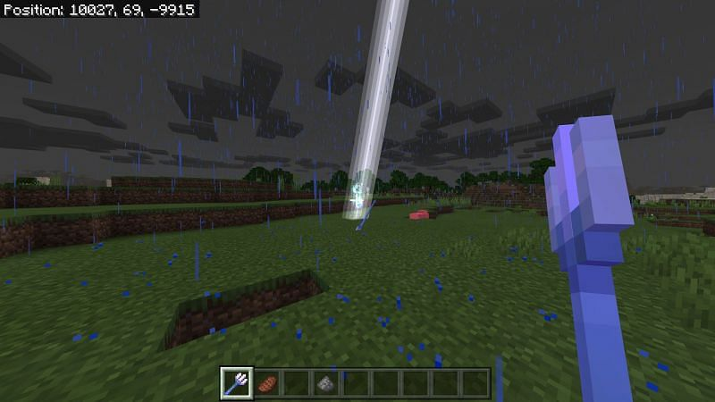

**2. Perfect weapon against aquatic mobs:** Impaling is a trident-exclusive enchantment in Minecraft. Tridents enchanted with impaling deal increased damage to aquatic mobs. The maximum level for Impaling is five. Level Five Impaling raises the melee and ranged damage by 12.5 health points.

Using an impaling trident, players can kill an elder guardian with only a few hits.

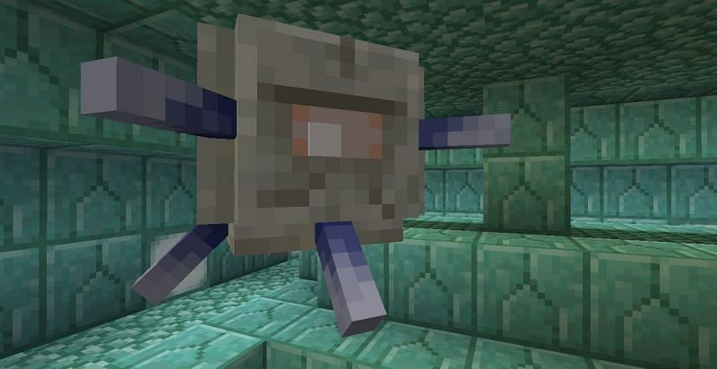

**3. Melee and Ranged attack:** Trident can be used both as a melee and ranged weapon. Players can use the left-click to do melee damage while holding and releasing the right button will launch the trident.

Melee attacks do four and half heart damage, whereas a ranged attack deals with four hearts.

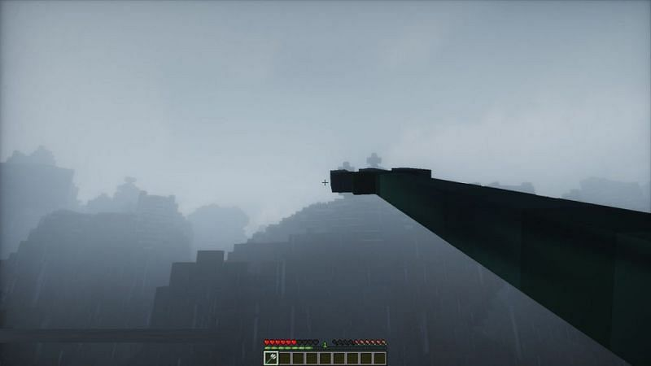

**4. Riptide and Elytra:** Riptide is one of the most amazing enchantments in Minecraft. Players can enchant their tridents with riptide to travel at a fast speed in water and rain. Riptide allows the players to achieve high speed when in contact with water. Players can use the trident to launch themselves into the air and then fly using elytra. It is a better way to start flying than using a rocket.

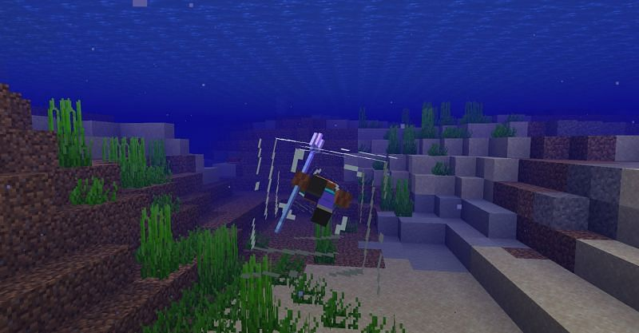

**Conclusion:** I hope this article helps you a lot in **how to make a trident in Minecraft**. Trident is the coolest earlier weapon in Minecraft, and it can you used in many ways. We can attack with the help of a trident. Share this article with your friends and have fun.

**Article by,**

**Noone Harshan**

**9550949044**